ACCESS CONTROL LIST

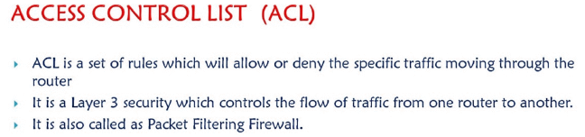

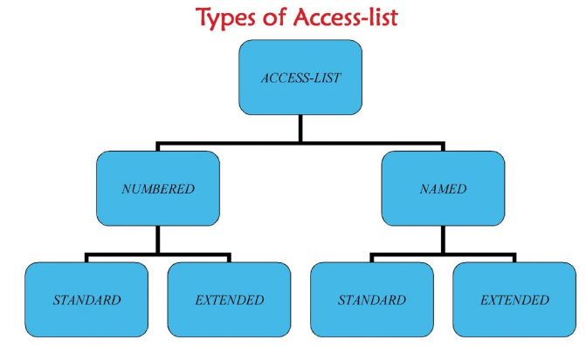

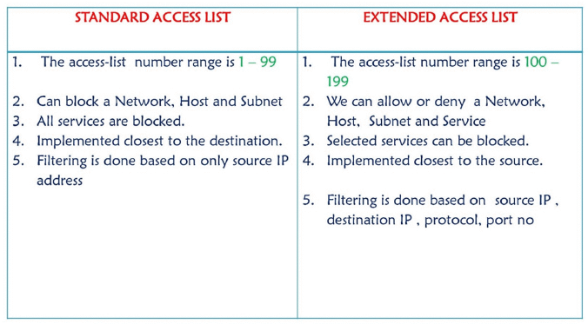

The main advantage we get in named ACL is we can add a specific line or delete a specific line form the list of rules written which is not available in numbered access list

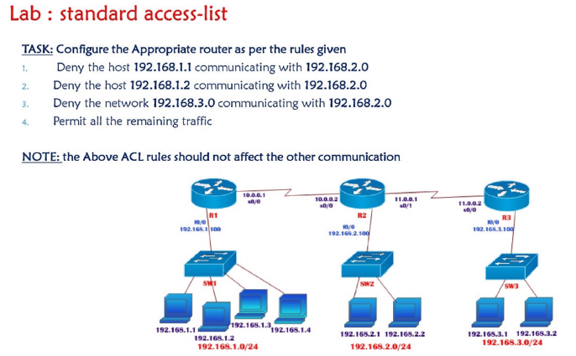

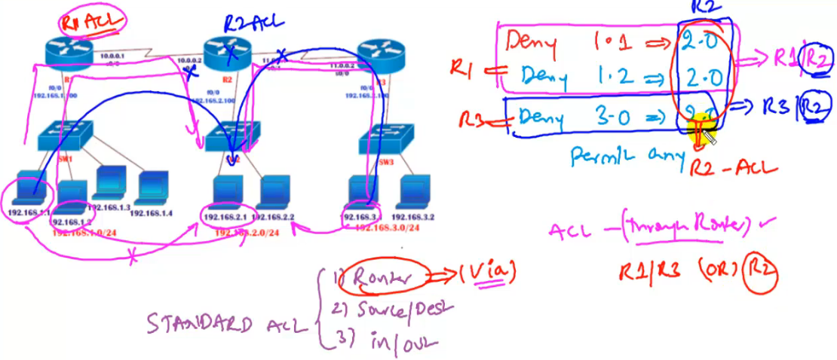

We can implement ACL on R2 since it is common or we can also implement ACL on R1 as well as R2

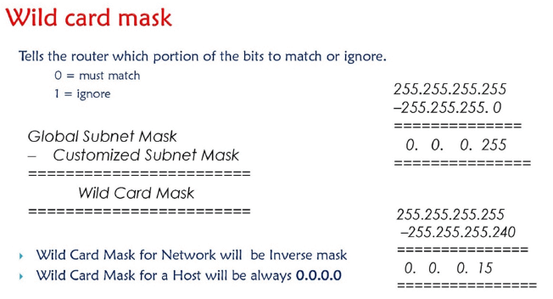

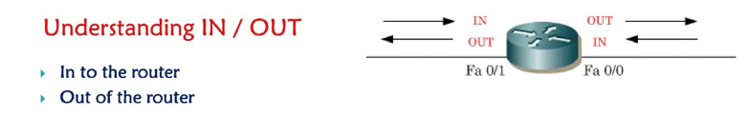





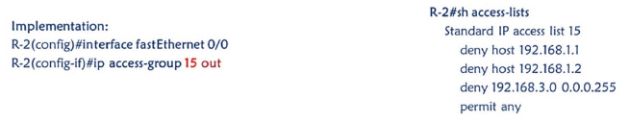

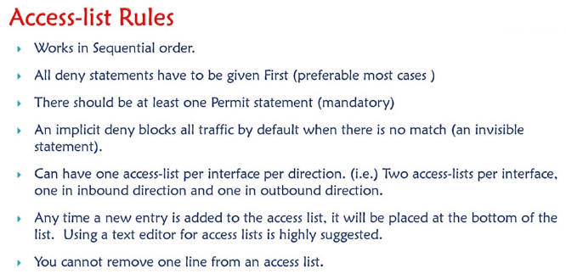

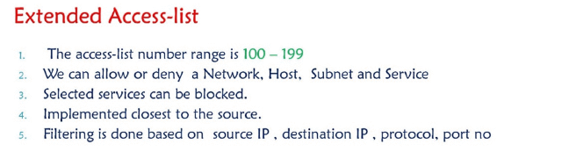

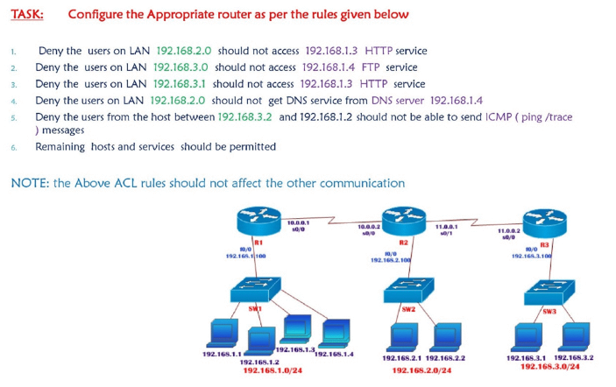

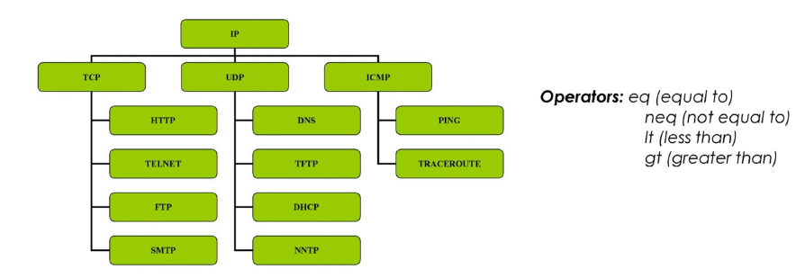

Eq = match only the packets which is equal to 80 example

Neq= other than 80 deny everything

Lt = deny/allow all port numbers lesser than 2000

Gt= deny/allow all port numbers greater than 2000

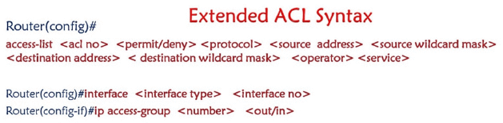

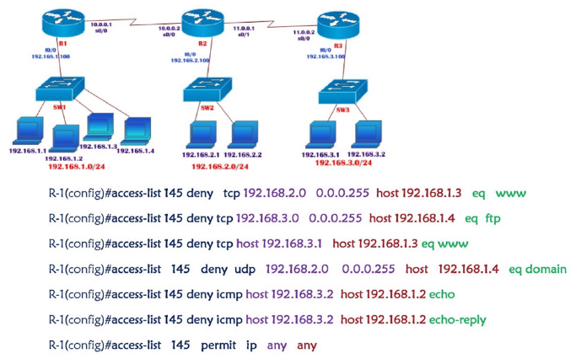



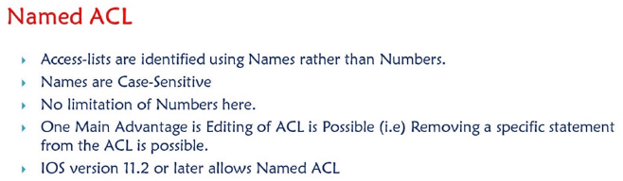

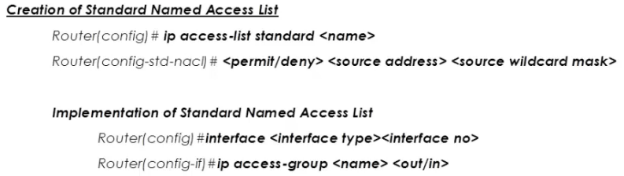

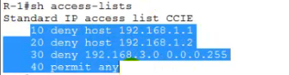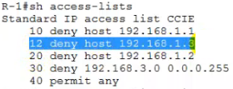

By default whenever we create acl sequence numbers (always in multiples of 10)will be added by default it is use to identify the acl s written , now lets say I want to add a new rule inbetween then I will use these sequence numbers , usually when I add a new acl it will add in the last but if I want to add it inbetween then *R1() ip access-list extended CCIE*

*If you want to remove any line then 12 deny host 192.168.1.3*

*R1() ip access-list extended CCIE*

No 20

So this way we can selectivily add or remove a specific line in case of ACL

IPV6

IPV6 was introduced to overcome the shortage of IPV4 addresses

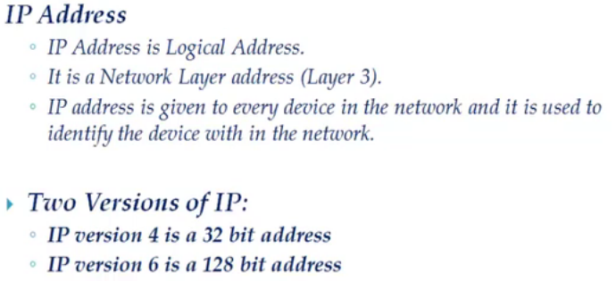

What is the Need of IPV6 address - We have 2 ^ 32 = 4.3 billion ip addresses but these ip addresses are not enough to meet the growing requirements , as the internet is growing at a very faster rate .

<http://www.ipv6now.com.au/primers/IPv6Myths.php>

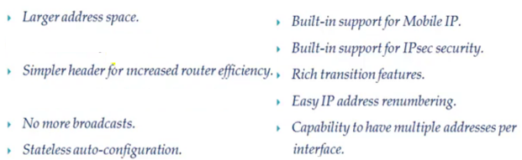



Global prefix interface ID

Unicast , Multicast and Anycast

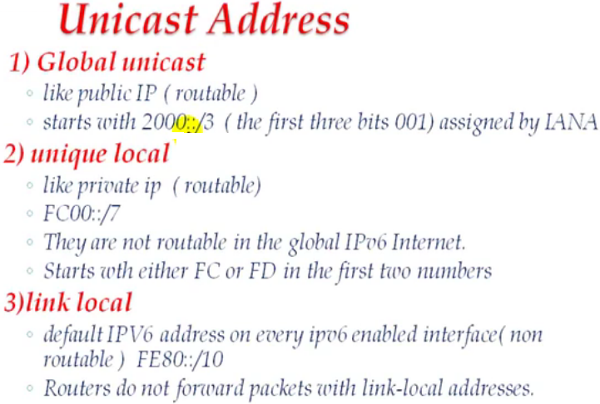

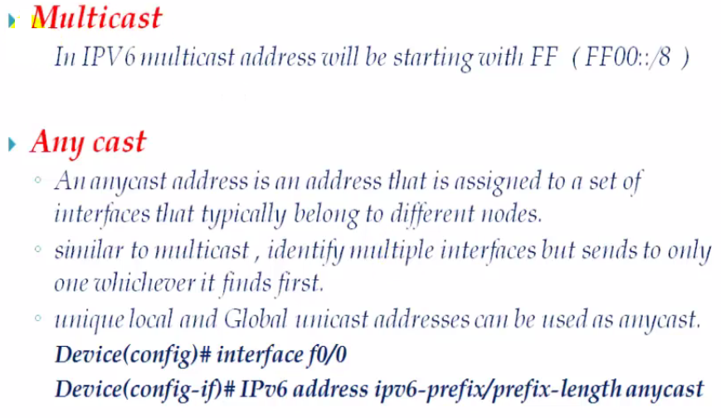

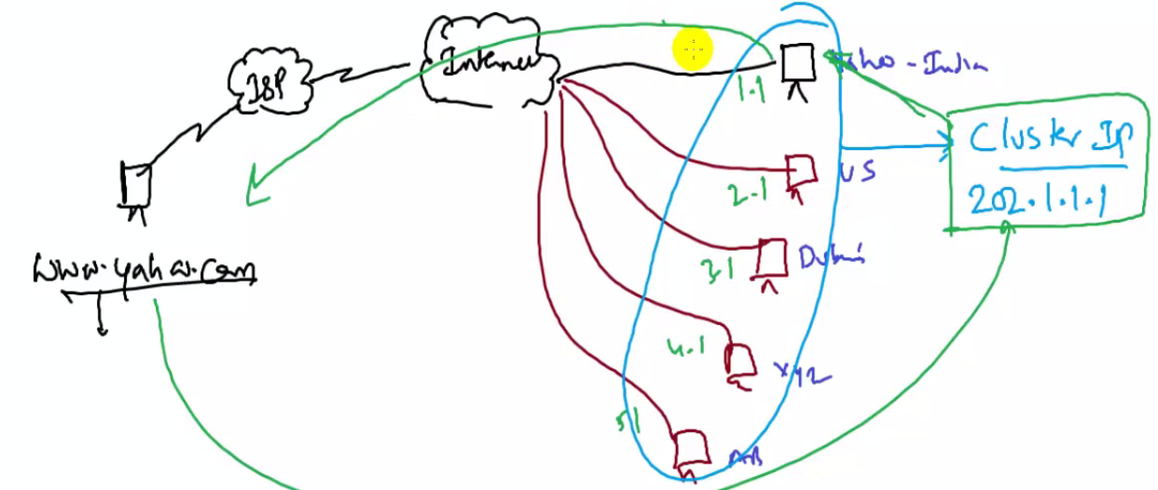

Stateless auto configuration – EUI 64 bit format

Assigning IPV6 address

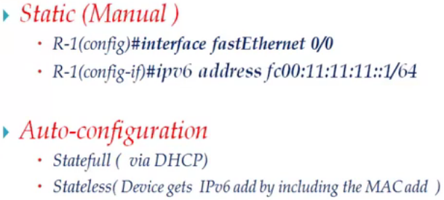

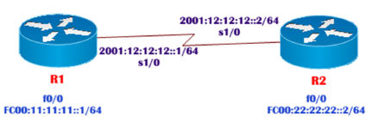

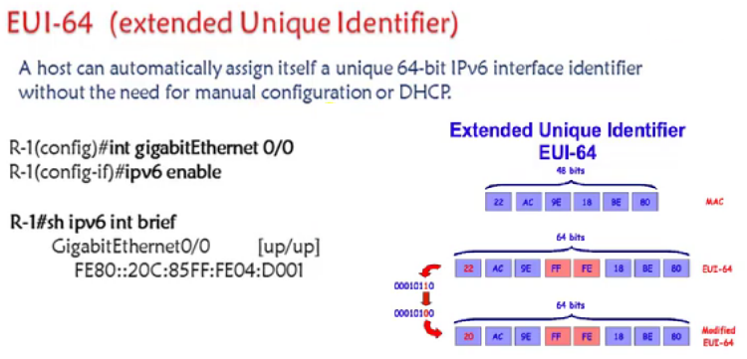

IPV6 routing types – Static , RIP ng , OSPF V3 , EIGRP – IPV6 unicast routing

Static routing

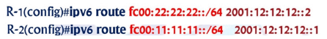

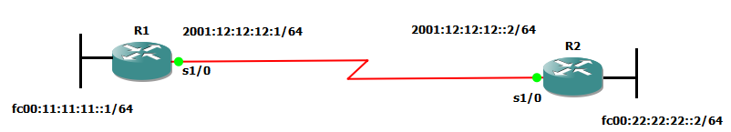

interface serial 1/0

ipv6 address 2001:12:12:12::1/64

no sh

exi

interface fastethernet 0/0

ipv6 address fc00:11:11:11::1/64

no sh

no keepalive

exi

ipv6 route FC00:22:22:22::/64 2001:12:12:12::2

exi

R2

interface serial 1/0

ipv6 address 2001:12:12:12::2/64

no sh

exi

interface fastethernet 0/0

ipv6 address fc00:22:22:22::2/64

no sh

no keepalive

exi

ipv6 route FC00:11:11:11::/64 2001:12:12:12::1

exi